1. Apply the transforms on your model(s) by selecting them and pressing ‘CTRL+A > Rotation & Scale’.
2. Go to the Material Properties panel and click the yellow dot next to ‘Base Color’. Select ‘Image Texture’ from the list and click ‘Open’. It will open a new window which you can use to navigate to the checker texture provided in class.

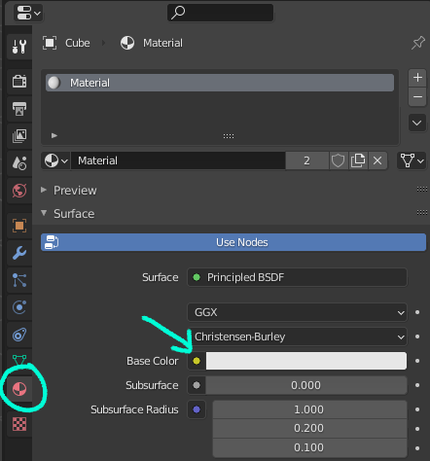

*Note: Once applied you will need to enable the ‘Viewport Shaded’ view to see the checkers which you can find either in the ‘z’ menu or the top right corner (symbol is a checkered ball).*

1. Go to the UV Editing tab at the top of the screen. *Note: You might need to re-enable viewport shading even if you have already done it.*
2. Assess your model and try to imagine how it might unfold. Once you have a plan, begin marking seams by selecting edges, right clicking, and selecting ‘Mark Seam’. *Notes: You can remove a seam by selecting ‘Clear Seam’ instead.*
3. When ready to unwrap, select all of the faces that make up the area you want to work with (or the whole object) and press ‘U > Unwrap’. Your mouse MUST be on the right side viewport for this to work.
4. Assess whether the unwrap was good or bad (see bottom of document for example). If good, repeat steps 4 & 5 for other areas of the model. If bad, check for missing or incorrect seams and mark / clear seams as needed or reassess your approach and consider a different way of unwrapping. Repeat process until the whole model contains fairly square checkers with little to no stretching.
5. When done, select all the faces in the 3D viewport (right) so all UV islands are visible in the 2D viewport (left). Select all the UV islands in the 2D viewport and go to ‘UV > Average Islands Scale’ (this will be at the top of the 2D window.) Once all the UVs are averaged, go back to the UV menu and select ‘Pack Islands’.
6. Take a moment to celebrate your success!

*What does a good UV unwrap look like?*For now we’re looking for fairly square checkers and no blobs or stretching. Example:

**

Notes: